1. Use the saved sample e-commerce database

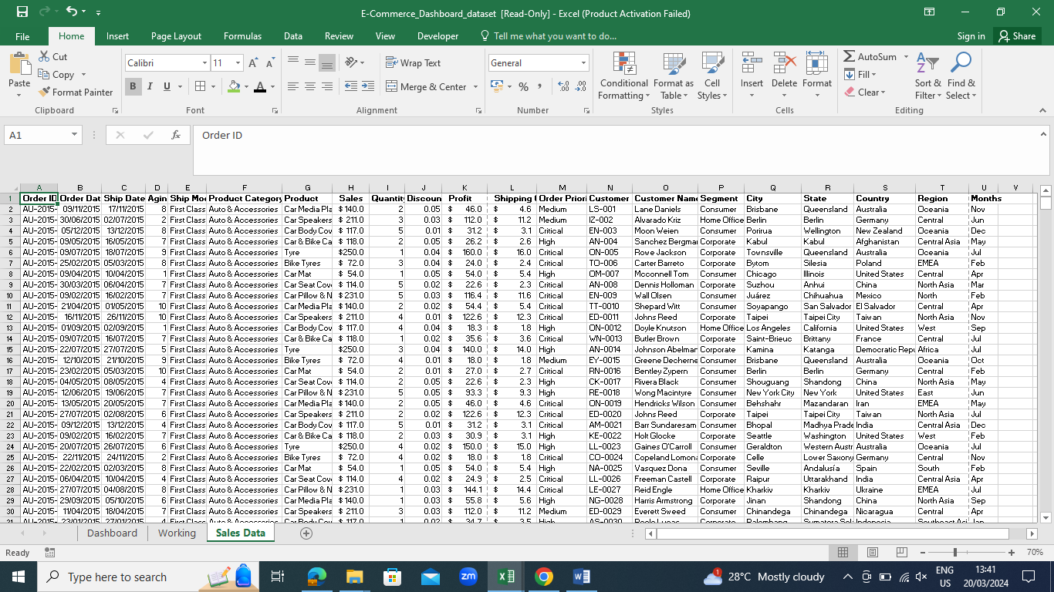

1. Create a Histogram for shipping days (aging)

• To create a histogram, click the Data tab, under the analysis group, and click on Data analysis.

• Now, select histogram and click ok. A histogram dialog box will appear.

• In the histogram dialog box, first, click the Label’s checkbox as you have labels in your data. • After that, in the input reference box select the range (“Sales Data!D1: D51291”) of our data, and in the bin range reference box select (“Working!K3: K7”).

• In the output section, select the range “Working!N3” for a binning table, click the histogram checkbox, and then ok.

3. Prepare a table of sales and profit month-wise in the working sheet

4. Prepare the sales table region-wise in the working sheet

5. Create a user control combo box for the product category

• Insert combo box for the product category list in the dashboard sheet

• Pass the input range and cell for the combo box

• Pass input range “Working!Q2:Q5” and cell link “Working!R2” from the working sheet

• Write the equal sign and then the function name

• Pass the first argument as Cell “$Q$1”

• In the second argument, select the cell “$R$2”

• In the third argument, type zero and close the parenthesis

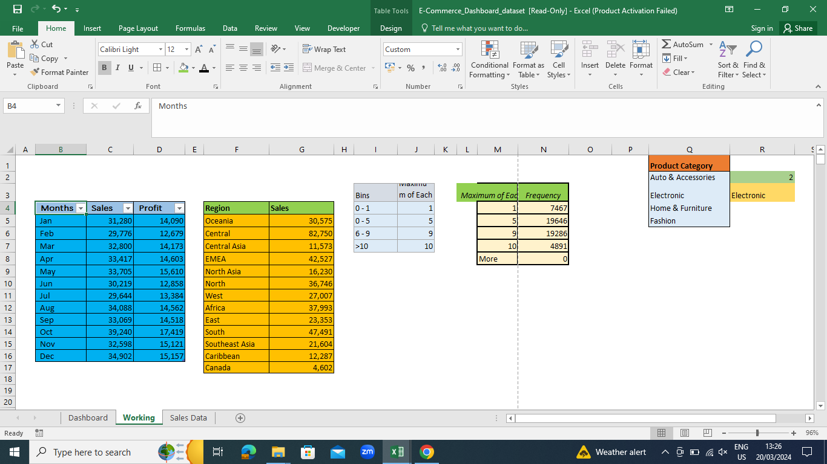

6. Create a column chart of the month-wise table and region-wise table

7. Link the table with a combo box

8. Create a dashboard and calculate the predicted and actual tip values.

9. Calculate the RMSE (Root mean square error) of the model.

